Rescue NGO Presents:

South India Youth’s On-Mass Addiction

To Watching Rape and Child Molestation

Research Paper

Rescue 108, 7th Main, Brindavan Extension 1st Stage, Mysore 570020
CEO Abishek Clifford abishekcliff@gmail.com Ph 08884146203

Intro

Rescue is an NGO has conducted moral awareness programs in 700 PUC, Degree and Professional colleges to 1,86,000 students in 11 cities / districts of South India, teaching against violent pornography, youth abortions, human trafficking, aids, irresponsible sexual behavior and rape. Abishek Clifford CEO of Rescue who was a statistics and ethics lecturer in London, carried out this survey.

Survey

The survey was carried out in 272 colleges in 4 States of South India to 5800 students. Clusters of 1 class per college with a quota of 24 students per class were asked questions indirectly about their friends. EG: “What percentage of guys your age watch rape videos?” “How much porn do they watch each week?” Target age was 16-21.

Violent Porn Addiction

Boys start on average in year 9 high school and 69% watch 6 hours of sex videos per week including child porn and rape. Porn addiction is epidemic, even in rural areas and is the latest bad drug, more addictive than cocaine.

36% of the college students watch violent porn, rape and gang rape. These watch an average of 19 rapes per week! This means that:

Each Year A Million More Students Get Addicted
To Watching Rape In South India.
(9,40,000 new students)

Through the internet: 13,000,000 Rapes Are Viewed by Youths Every Day In South India! (Please see note below^{*1} for details of this calculation)

52% of the boys who watched soft core porn ended up watching hard core porn. 84% of students said that porn is a progressive addiction just like drugs. Satisfaction is lost for normal porn and so after a few years the desire comes automatically to view younger more ‘innocent’ school girl porn and violent porn (rape). 85% said porn leads to sexual activities. During their PUC and Degree time those 36% of male students who watch rape will each see a total of 4,900 rapes on their mobiles or digital device! 69% of students said that watching rape gives the desire to actually do a rape. Even if only 10% of them act on this desire, this means we are training up 64,000 new rapists a year in South India through internet rape porn! We can no longer deny the link between watching rape though porn and reaping an ever increasing harvest of violent rape and abuse in India. The reason why the level of violence in the rapes is increasing and the average age of the rapist is decreasing is obvious. The whole business world knows that what you see in your TV advert changes your choices and affects what you purchase. Porn advertises rape! Since it is illegal to advertise cigarettes and alcohol why are we allowing the advertising of child molestation? If we want to reduce rape we must stop violent sex videos being viewed on mass in India through the internet.

Maths*¹ for 13,000,000 rapes per day

Present population estimated at 270,000,000 * 1.9% of population in each year group at this age (2011 census) /2 (only boys) * 36 % boys watch rape * average 2.7 per day watched * 5 years of college for this 16-21 age group = 13,000,000 (This assumes our results are similar for non-studying youths of the same age – an assumption backed up by our research – in fact non studying boys watch more)

Recommendation 1
99% of porn is from the internet. The government should block all web sites which have videos of children (<18) being raped or ones with links to other sites that have this content. This amounts to approximately 50% of porn sites! It is already illegal to transmit porn (IT Act sec 67a) and the internet transmits day and night. After the government blocked 850 porn web sites for a few days many complained that people should have the right to watch what they want in private and the government should not police the internet. However the internet is not within 4 walls, it is the most public place accessible day and night by any age adult or child. Also we have to police every area of society including the internet. Why do we want to move away from civilized life and return to lawlessness in one area. Even to mention the names of some of these sites would be unacceptable in most schools let alone allow their students to see the content. The 4 day block proved that blocking porn is not impossible. It is a distorted idea of democracy that calls for zero regulation in any area of society.

One Hundred Thousand Teenage Girls Locked Up In Brothels Raped 7 times Every Day In South India:

100,000 High school girls Gang raped per day

Sources:
50,000 NHRC national human rights commission Sunitha Krishnan Prajawala who won the Padma Shree award always quotes NHRC Stats as NCRB is only for cases where FIR is filed. This figure from recent NHRC is available only in hard copy, not on net.
140,000 BBA http://www.bba.org.in/sites/default/files/Synopsis.pdf
“If the average number of 150 reported missing children per district (from available data) is extrapolated to all 640 districts in the country, the total number of missing children in India every year would come to the tune of 96,000.”
Calc: 96,000*7 years average lifespan / time in brothel=6.7 lakhs (rounded nearest lakh) under 18 India 6.7/12900 pop India lakhs * 2700 pop South India = 1.4 Lakh

270,000 CBI (Ashwani Kumar) 13,00,000 pa India (CBI total trafficked children present in India) interpolation /12,907 lakh (pop India) *2700 Lakhs (Source: child prostitutes in India Ashvani Kumar, former head of Central Bureau of Investigation (CBI) CNN reported may 11th 2009) http://edition.cnn.com/2009/WORLD/asiapcf/05/11/india.prostitution.children/index.html?iref=24hours

30,000 NCRB National Crime Records Bureau for 2014 approximately 21,000 (children under 12 and girls under 30 were abducted without specified) /12,907 lakh (pop India) *2700 Lakhs =4400pa *7 years =31000. (However in every district many more cases where the parents of missing children gave clues to the police, their complaints were only recorded in the station records but no FIRs were lodged and investigated.)

NGO’s , WHO, UN quotes much higher values eg: http://nipccd.nic.in/reports/ehndbk10.pdf National institute of public cooperation & child development

Average 1.2 Lakh

Sexual Offences Against Children In India Have Reached Epidemic Proportion (336% increase in 10 yrs).
http://www.ibtimes.co.uk/child-sexual-abuse-top-5-countries-highest-rates-1436162

Why Is Human Trafficking Of Minors Increasing:

Child Porno And High School Girl Sex Slaves

Porn watching leads to a desire to see younger and younger naked girls on their mobiles. 48% of students watch ‘teen porn’. This is where the porn star is a high school girl. The students were asked what % of web sites had teen porn and the average answer was 43% even though it is meant to be illegal internationally. 6.1 million male youths watch child porn. They state they desire videos of more and more innocent, younger girls. Porn turns good men into paedophiles. The demand for this sort of porn is met by brothels (prostitution centres) throughout the world, who purchase kidnapped high school girls on-mass, who are then forced to make porn in-between satisfying customers. 72% of boys say watching porn inspires them to use prostitutes. After watching child porn 24% of degree-age students go to prostitutes, that is, 3 million youths demand a very ‘young’ prostitute to try out what they have seen. They say they want to experience it once after years of watching it but are hooked after one try.

Indian girls are being abducted, tortured, raped, starved, and drugged until they comply with their new owners to be submissive sex slaves and youth porn stars. They have to serve 7 men a night locked up in a room like prisoners, never allowed out, for an average of 8 or 9 years until they die of AIDS, other STDS or trying to escape. (NHRC)

How can we allow the male youths to fuel such a terrible massacre and violation of the daughters of India? Watching teen rape obviously inspires teen rape, hence all what we have seen in the recent news.

Further Recommendations

Cyber ethics should be introduced as a part of the syllabus in college first year and higher secondary school.

Before our programs 24% of the girls said that porn was harmless, after our programs only 5% believed that. Similarly before our programs 26% girls said that it was ok to get pregnant and have an abortion whereas after our program this reduced to only 3%. This shows how education on these issues can counteract the unhealthy, unethical, unrealistic influences in the internet. Through just one 2 hour seminar 84% of promiscuous attitudes changed. 97% of boys said they were changed by one cyber ethics seminar and 91% of them said they would install porn blocking software after the awareness program, showing the effectiveness of carefully addressing these issues with the students. We have a petition of 375 College principals recommending that cyber ethics be taught in PUC and Degree level colleges.

Buying Porn

62 % of the boys said porn is accessed primarily through internet on their own mobile or home computer, however when they started watching porn in high school, 52% of them said they obtained it from cyber cafés, DVD shops and download shops. If we want to address this issue a huge help would be to enforce the law in these public areas. Public should campaign until all internet rape porn is completely blocked and report any cyber café that does not have porn blocking software installed. Police should be informed on any download centre selling porn to boys. Cyber cafés are required by law to install porn blocking software, to protect high school boys who regularly use these computer centres. At present in South India approximately more than a million high school boys each day download sex videos from these cyber cafés who have not installed this legally required blocking software. Police should check this and they should also raid download shops. 390,000 high school boys each day buy porn from these shops in South India. We gave this research to the commissioners / superintendents of police in each city/district we surveyed and they gave positive signs of taking action to reduce this. We conducted raids with many of them, leading to a total of 10 porn sellers being jailed and bailed.

All high school parents should be sent letters explaining how to put parental software on their children’s digital device. This is free and blocks all porn and gives the parents a weekly summary of what their child is doing in the cyber world.

Girls

Girls were shyer to share results, even in written format. The questions were answered by, on average, 57% of them. Boys were not shy at all. 99% answered. According to the girls who answered 34% of degree girls in South India watch porn and they watch an average of 5 hours per week of these sexual content videos.

Risky Sexual Behaviour and reversed Sexual Orientation

According to the Bangalore survey 52% of porn web sites have homosexual porn and 56% have unhealthy anal and oral sex depiction. Girls complained of being forced by boyfriends to do things with them that they felt uncomfortable with otherwise the boy threatened to break of the relationship. Girls said their boyfriends made them watch porn and told them to do the same. Many girls complained of relatives and friends abusing or pressurizing them into sexual activities. 84% of the Bangalore boys and 91% of the girls said that watching anal / oral porn inspires them to try it out, on a girlfriend or more likely a prostitute. In Bangalore 87% of the boys said porn inspires the use of prostitutes.

Anal and oral sex is extremely unhealthy. Surveys among heterosexuals on these topics are limited however these methods are the only options for homosexuals. We can see how risky such behaviour these are by looking at statistics on sexually transmitted diseases among homosexuals. In India this community is often secret about their orientation but they are very bold and open in western countries. In USA homosexuals are 140 times as likely to get HIV/AIDS (see below). According to India limited data they are 16 times more likely to get HIV/ AIDS (see below). Homosexuality shortens people life by on average 14 years (according to the 2 reports on page 6). Since we seek to shun smoking that reduces life by 7 years how can we promote something that is twice as deadly? From this we can see that anal and oral sexual activities advertised in hard core pornography reduce life span by one fifth; that is 20% suicide. This is what we are training our youths to do.

Watching porn inspires students to experiment with same gender sexual activities and transition from heterosexual to bi-sexual. In ecstatic states they not only watch the body parts of the opposite gender but the same gender as well. Also they report of getting bored with similar porn and progress onto this type for a ‘fresh experience’. Porn is responsible for influencing the younger generation into types of relationship which are very risky and destructive medically, those of the same gender. The CDC USA reported (see page 6) that 92% of youths with HIV/AIDS were engaged in homosexual activities! Also this root also may be a fast track to developing paedophilia. Homosexuals are 24 times more likely to become paedophiles compared to heterosexuals. (see below). When teaching these facts in Banglaore Medical college recently some students came up to me at the end and showed the same statistics in their text books. They said that they know about this but that other youths had never been warned.

USA: Homosexual Men Have 140 Times Chance Of HIV

MSM (men who have sex with men) is 2% of USA but 56% of HIV cases are MSM
Heterosexual men are 50% of USA and 10% HIV cases are Heterosexual men
SOURCE WWW.cdc.gov/hiv/nsk/gender/msm/facts
MSM : Hetero Men 2:50 => 1:25
- Hetero = 25 x MSM *1
MSM HIV : Hetero HIV 56:10 => 5.6:1
- MSM HIV= 5.6 x Hetero HIV *2
*1 / *2 5.6 x Hetero HIV = MSM HIV
Hetero 25 x MSM
MSM Proportion HIV = 5.6 x 25 x Hetero Proportion HIV
MSM Proportion HIV = 140 x Hetero Proportion HIV

INDIA: Comparison Of HIV in Homosexual and Heterosexual

SOURCE : http://timesofindia.indiatimes.com/india/HIV-claimed-60000-less-lives-last-year-in-india/articleshow/17434033.cms
2011- Total 0.27 adults MSM 4.43%
MSM cp to Total 4.43 = 16
0.27
=> India homosexual are 16 times more likely to get HIV cp to other adults
This is so different from foreign results possibly due to the reluctance of Homosexuals in India to reveal their orientation.

Homosexual Are 24 Times As Likely To Become A Pedophile Cp Heterosexual

“Tragically some of the many partners of some homosexuals are children while male homosexuals comprise only 2-3 percent of male pop they commit about 1/3 of all child molestation cases. That is one third of all paedophile cases are homosexual in nature man to boy.”
“The best epidemiological evidence indicates that only 2 to 4 percent of men attracted to adults prefer men (ACSF Investigators, 1992; Billy et al.,1993; Fay et al.,1989; Johnson et al.,1992); in contrast, around 25 to 40 percent of men attracted to children prefer boys (Blanchard et al.,1999; Gebhard et al.,1965; Mohr et al.,1964). Thus, the rate of homosexual attraction is 6 to 20 times higher among pedophiles."
Ray Blanchard, et al., "Fraternal Birth Order and Sexual Orientation in Pedophiles," Archives of Sexual Behavior 29 (2000): 464. Quoted by following but all over the net: https://www.frc.org/get.cfm?i=is02e3

Ratio of Homo Pedophile : Hetero Pedophile
1/3 : 2/3 i e 1 : 2
=> Num Homo pedophile = ½ Num Hetero pedophile *1
Ratio of num of Homosexuals : Heterosexual Males
2 : 98
=>Total Homo = 2/98 Total Hetero *2
*1 / *2 Homo pedophile = ½ Hetero pedophile
Total Homo 2/98 Total Hetero

=>Prop Homo pedophile = ½ x 98/2 x Prop Hetero pedophile
Proportion Homosexual pedophiles = 24.5 x Proportion Heterosexual pedophiles

Homosexual’s life span shortened by approx. 14 years average (8 to 20 years).
  - John r digs jr MD the health risks of gay sex - corporate resource council 2002 available www.corporateresourcecouncil.org/white_papers/health_risks.pdf
  - RS hogg sa strathdee, kj craib mv o shaughnessy js montaner modelling the impact of HIV disease on mortality in gay and bisexual men - international journal of epidemiology vol 26 657-661 www.ije.oxfordjournals.org/cgi/content/abstract/ 26/3/657

Average 92% of HIV cases among male youths were amongst Homosexuals (CDC USA)

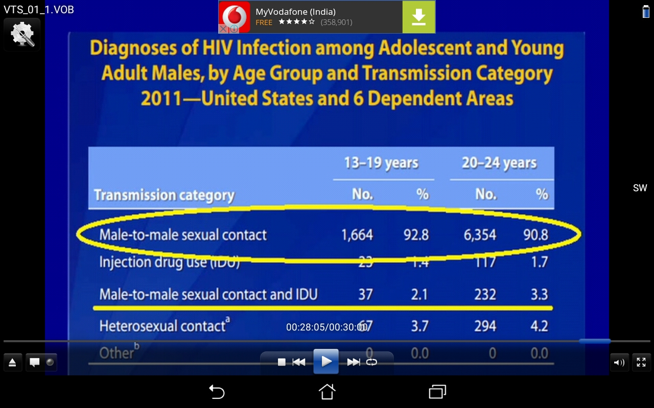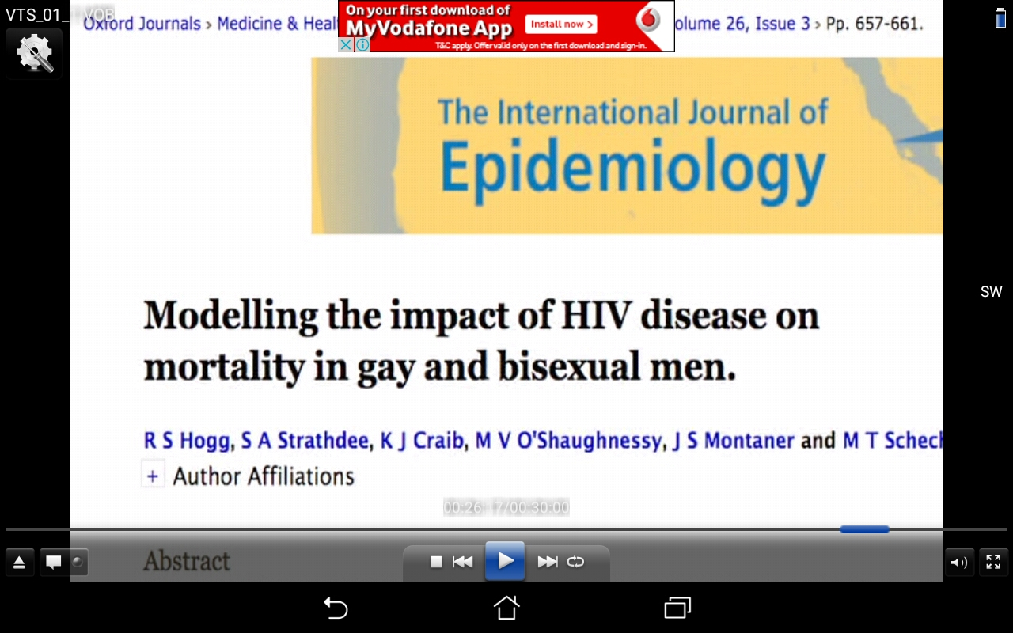

The best epidemiological evidence indicates that only 2 to 4 percent of men attracted to adults prefer men (ACSF Investigators, 1992; Billy et al.,1993; Fay et al.,1989; Johnson et al.,1992); in contrast, around 25 to 40 percent of men attracted to children prefer boys (Blanchard et al.,1999; Gebhard et al.,1965; Mohr et al.,1964). Thus, the rate of homosexual attraction is 6 to 20 times higher among pedophiles." Ray Blanchard, et al., "Fraternal Birth Order and Sexual Orientation in Pedophiles," Archives of Sexual Behavior 29 (2000): 464. Quoted by following but all over the net: https://www.frc.org/get.cfm?i=is02e3

Youth Pregnancies
30% of degree age students have sexual relations with their lover and 12% of the girls get pregnant and have MTP during their college life. Each year half a million girls this age in South India get pregnant and have abortions. Marriages ruined, children fatherless, increased suicides and social unrest are all the fruit of on mass porn addiction.

Youth Abortions | Pa South India
abortions pa from % abortion | 310,000
Abortions pa calc via fornication | 590,000
abortions calc from AIIMS assuming 20% youth | 460,000
average of estimates abortion 1SF | 500,000

On average youths see 82,000 naked ladies video clips by the time they are married. What chance will their wives have of being able to satisfy them long term?

Whilst highlighting the problem in South India we are doing a national survey and are not suggesting that this area is the only bad place, it is bad everywhere.

The Average Standard deviation in the results across 12 districts was 9%. I.e. the results across south India were 91% similar. I.e. regional variations were minimal. This is a national problem. However the results for rural and vernacular medium students on average were about 10% less. Bangalore was 60% higher (see below).

Extra Recommendations

There should be a division of cyber police in every state of India which deals exclusively with internet porn. The existing cyber police cells are fully busy dealing with hacking, terrorism, and internet fraud. There are approximately 2 crore porn web sites. A software solution is needed to identify them. This has already been achieved by multiple companies producing parental and porn blocking software and apps. Current home computers can do 200 crore calcs per second (2GHz). 2 crore web sites is not a big number for computers. Google and Microsoft have child porn tracking software solutions that they are freely sharing. Many countries like China and Saudi already block porn. A court case is not necessary as how could the Indian government finish 2 crore court cases? And the IT act 2008 section 67A already criminalizes transmitting porn which is what a porn web site does day and night. It is true that there are ways round blocks but then you work on stopping those. We have viruses but then we have anti-virus. More virus’ come then we program anti-virus upgrades. Porn needs to be fought the same way internet virus’ are. Foreign countries use tracking methods to see who is watching child rape then they are punished and publically shamed. This stops foreigners accessing this porn from their own mobile and instead they go to cyber cafés. However in India you have to show ID proof before you can use cyber cafés… Some parties do not want porn to be blocked that is the problem! People who have compromised their integrity and fallen into the habit justify this illegal, degrading, immoral activity and are reluctant to implement the law. Low resolution screens can be used for senior lady police officers to check whether debatable sights should be blocked without compromising their integrity. ISPs and mobile companies should be held responsible if companies advertise porn through texts on their networks. Yes we want freedom in India, but how about the freedom of the ladies and girls being abducted, abused and raped on mass in these times? There is no freedom to walk around naked in India in public. Internet is public place. If we allow children to watch porn then would we allow porn stars into high schools to strip and have sex in assembly? Is there freedom for that? Then there should be no freedom to have sex in the public place of the internet let alone rape!

Advice to Parents

Parents should install free ‘parental software’ on their computers and children’s smart phones which blocks all porn (e.g. k9) and makes it very easy to monitor what their child is watching and doing on the net. They can just Google ‘parental software’ and install it in 10 minutes. Regularly they should check their child’s mobile’s inbox and files, become ‘friends’ with their Facebook account to see what they are saying and if they don’t know how to do all this they can just ask a friend who does.

Comparing Bangalore to South India

 |  | % WATCH RAPE | Rape bf / week | % sleep with lover | % use prostitutes | % ABORTION
South India |  | 36 | 19 | 31 | 25 | 12
Bangalore |  | 63 | 26 | 39 | 38 | 21 | average
% increase |  | 73 | 37 | 40 | 70 | 76 | 60

In terms of addiction to violent porn, promiscuity, youth MTP’s and use of sex workers Bangalore was on average 60% higher compared to the rest of south India. Other places were 91% the same as each other. However only 20% colleges in Bangalore made time for our awareness program compared to 80% on average across South India. Has education become a pure business here in Bangalore, a minority of the institutions really caring for their students? Is the adult generation so far out of touch with the problems and issues of the youths?

HT Bangalore: 4000 High school girls, Gang raped per day in Bangalore Brothels
1140 NCRB National Crime Records Bureau for 2014 approximately 21,000 (children under 12 and girls under 30 were abducted without specified) /12,907 lakh (pop India) *100 Lakhs
(pop Bangalore City)=163pa *7 years =1140
2000 NHRC 11,000 national human rights commission /550 lakhs population Karnataka*100 lakhs population Bangalore city
4200 BBA report 23,000 (Bachpan Bachao Andolan) /550*100
10,000 CBI 13,00,000 pa India (CBI total trafficked children present in India) interpolation /12,907 lakh (pop India) *100 Lakhs (pop Bangalore City )
Average 4000
For sources see links above in south India human trafficking section. (page 2 & 3)

220 Medical shops and Cyber Café’s
Single unmarried girls from our team visited 220 medical shops. 161 illegally gave MTP tablet (w/o prescription) and 59 did not give. 2 videos of this occurring in Bangalore with audio in Kannada are on the DVD with all the data of this survey. Illegally giving out MTP kits emboldens girls to promiscuity without any worry about pregnancy.

About 80% of the hundred + cyber café’s we tested had not installed the legally required porn blocking software (according to the 2011 guidelines for cyber café an offshoot of the 2008 IT act). We did raids with police in Belgaum Gadag and Mysore.

Correlation
We compared the amount of porn consumed and the amount of sexual activity amongst the students by areas. The correlation between this root and fruit of sexual activities across different states was inconclusive (max Spearman’s Correlation Coefficient 0.46) due to low average 9% standard deviation of the values. That is the variation of the levels of promiscuity was only average 9%, i.e. the data was 91% the same in each area of south India. The only distinct difference was rural and Kannada medium were on average 5% better than urban and English medium, probably due to these students obtaining easy access to internet porn at a younger age (smart phone home computer more cyber café’s etc) However overall the regional variation is irrelevant, even for local language medium colleges in rural areas the level of indecency is clearly unacceptable. Moreover 90% of students, more humble than adults, admitted that porn was addictive, progressive, and led to explore sexually irresponsible habits and activities as detailed earlier in the report.
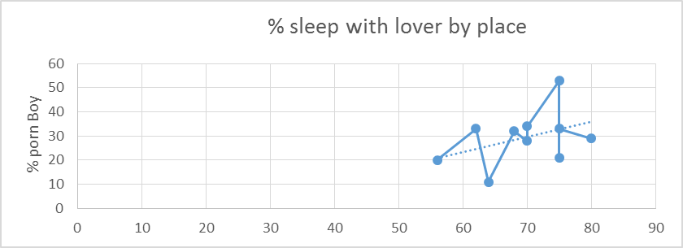

Districts, Cities / States Surveyed:

Tamil Nadu: Coimbatore, Chennai
Goa: North and south
Telangana / Andra: Hyderabad
Karnataka: Mysore, Mangalore Udupi, Chamaraja Nagar, Bangalore, Hubli, Bidar,
Gadag, Belgaum, Mandya

Kerala was the only state of South India where so far we have not conducted surveys. We are planning to take a team to 3 cities and towns there soon. Our Aim is to survey all India then file a PIL in Delhi requesting the Government to block rape and child porn sites in India.

Conclusions

Pornography is a cancer that eats away at the emotional and ethical state of a person. It is the bait that’s used to hook its unsuspecting victim to a lifetime of sexual turmoil. It’s method is to fill a legitimate need illegitimately. The core issue is deeper than most may think or imagine. We can use comparisons to understand its attack strategies. Would we allow men outside schools handing out Pornographic Magazines like Playboy to the children? That is exactly what is happening through the internet.

The schools and colleges don’t need sex education, they already have that, a very dangerous, unhealthy version of it, from pornographic web sites. They need ethical teaching on why we have tradition values of abstinence and self-control. The students never hear any of these arguments but rather through films and adult web content they are taught a version of sex that has no respect for commitment, marriage, love, health, or gender. Since teachers are embarressed to discuss these taboo issues and since smart classrooms are now common, cyber ethics videos can be produced to cover these subjects. Rescue can supply these freely to state governments on request. We have already distributed hundreds to individual colleges after our programs.

If a foreign army captured one city on the edge of India, putting 100,000 Indians in prison, making them slaves, raping the women every day, would India put up with it? That is exactly what a huge gang of pimps have done in this land. They have brought back slavery to independent India!

Rescue till now has received no funds from Government or CSR companies but is supported mostly by sponsors who 15 years ago got free from porn in our programs and are now happily married. We plan to start teams / branches in many states of India.

People are switching in educational establishments to audio visual training in smart classrooms. What is pornography? Audio visual training on how to rape a 16 year old girl, and how to practice very unhealthy sexual activities. We can no longer deny the link between hard core porn and the increase of rape, abuse, sexual harassment and human trafficking.

Same people who espouse total freedom in choice of sexual partners and genders are the most vocal voices of shock and outrage at the numbers of aids orphans and child sex slaves in the world. They are blind to their own hypocrisy and denying the fact that the very freedoms and lifestyles they espouse are a primary causes of the things they are outraged about. “Freedom supersedes morality!” NO!

These disturbing statistics are given to authorities including
those in the police and education departments and demand
serious debate and action. Unchecked, the consequences on
Indian families, children and society will be devastating.

Rescue 108, 7th Main, Brindavan Extension 1st Stage, Mysore 570020 CEO Abishek Clifford
Email: abishekcliff@gmail.com Phone 08884146203 English Viji 8550877781 Kannada

